**Development of Exam Screen:**

*Reference URL*: <https://www.embibe.com/engineering/test/jee-main/chapterwise-test/physics/laws-of-thermodynamics/paper>

Requirements:

1. Screen should have responsive (automatic change the layout as per Laptop/desktop/tablet/mobile). So kindly use bootstrap for that.
2. Project should be done in Asp.net, C#. Any client side framework can be used such as JQuery, AJAX, JavaScript, 3rd party controls etc. to incorporate the functionality stated
3. Final goal/outcome is : It should behave as per above URL.
4. Add-on to that Next & Prev buttons should be there to navigate/display the next or previous questions.
5. Question Overview panel should have Attempted, Not Attempted, To be reviewed, Not viewed yet & Attempted & marked for review options with the respective behaviour as shown in above reference URL.
6. Question Overview panel should have menu based Show/Hide feature which is very useful for small screens such as Mobiles or may be tablet.
7. Kindly refer Desktop View & Mobile View below snap for the reference. Also, have a look on the behaviour, kindly check with above reference URL.
8. Configurable Periodically Auto-Save should be happened so that if internet connectivity goes down & student reload the state then at least it should restore it till that last auto saved option did that work.
9. After Finish button or Exam time out, Exam should submit the Exam to mock method.
10. If user clicks on Finish button, there should be confirmation pop-up to confirm as shown in snaps

What we need to provide to start this functionality development is?

1. Basic skeleton of ASP.net project with few entities & Mock methods.
2. Below would be few mock methods
3. List<QueAnsVO> GetExamQuestions(long examId) - which will provide few mockQuestion-answers.
4. FinishExam(List<QueAnsVO> studentSolvedUnsolvedAllQuestions) – empty method which expect the List<QueAnsVO> studentSolvedUnsolvedAllQuestions. This can be saved in DB via DAL by our program.
5. PeriodicSave(List<ResultVO> studentSolvedUnsolvedAllQuestions) – empty method which expect the List<QueAns> studentSolvedUnsolvedAllQuestions. This can be saved in DB via DAL by our program.
6. Save(ResultVO studentSolvedUnsolvedQuestion) – This method is responsible to save a particular question/answer which student has done action i.e. (save, next, prev, review later)
7. Can create necessary mock methods & entities if required.

**Snap 1 : Desktop View (Exam Screen)**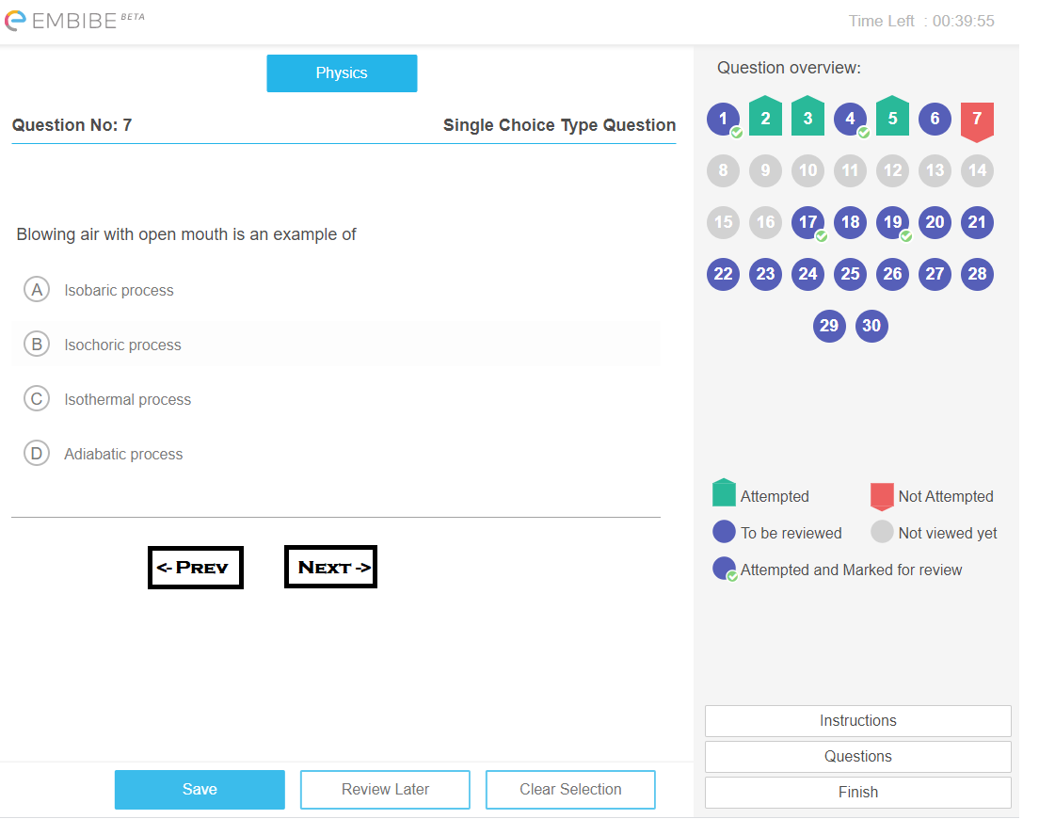

**Snap 2 : Confirmation Popup on Finish Exam**

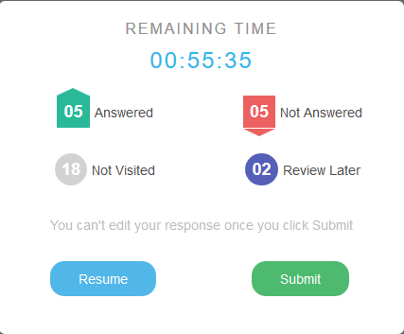

**Snap 3 : Mobile View (Exam Screen)**

